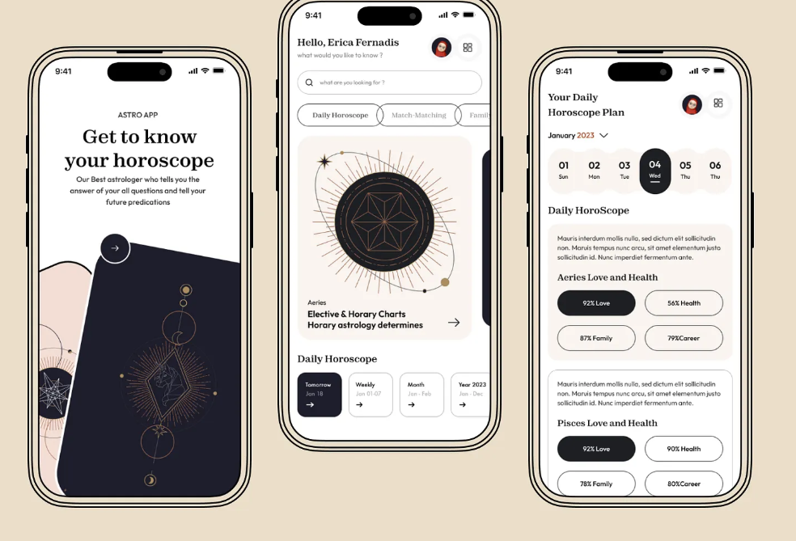

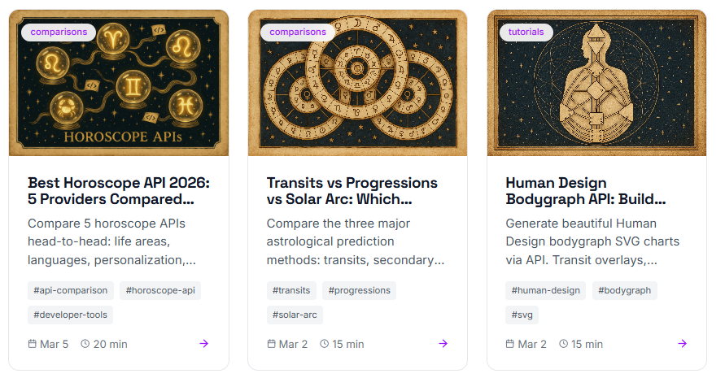

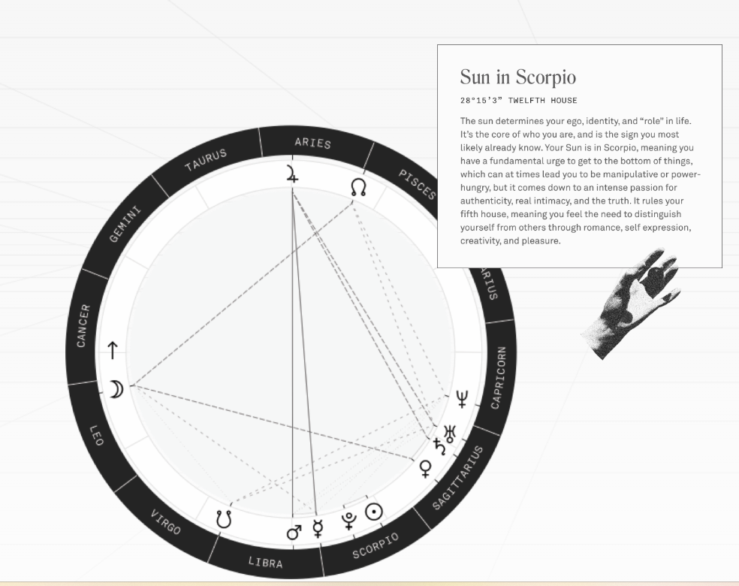

The chart screen should feel like a personal identity card, beautiful enough to screenshot and share.
Reading tone should feel like a wise elder
Every screen, even negative readings, must end on a growth-oriented note. Visual design should use warm, calming colors, not anxiety-inducing dark themes.

